**EXPERIMENT-3**

Name: Aditya Agarwal  
SAD ID:500069294  
ROLL NO: R171218007

**Jenkins integration with Maven and GitHub**

To integrate Jenkins with Maven we need to install maven integration plugin.

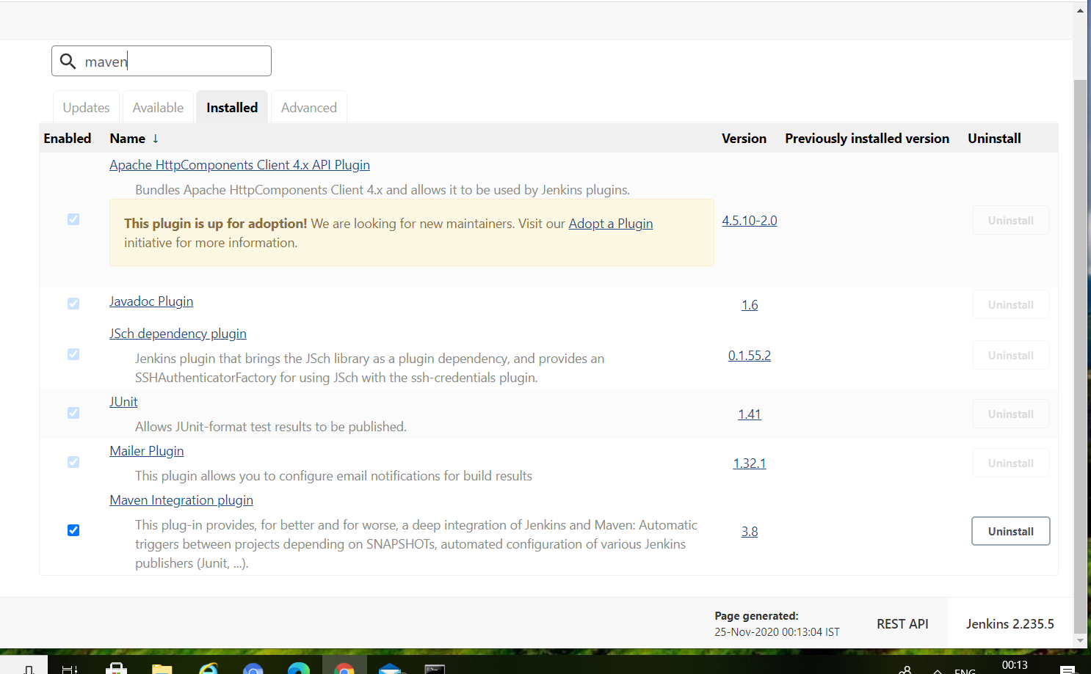

Go to Global Tool configuration and add maven path

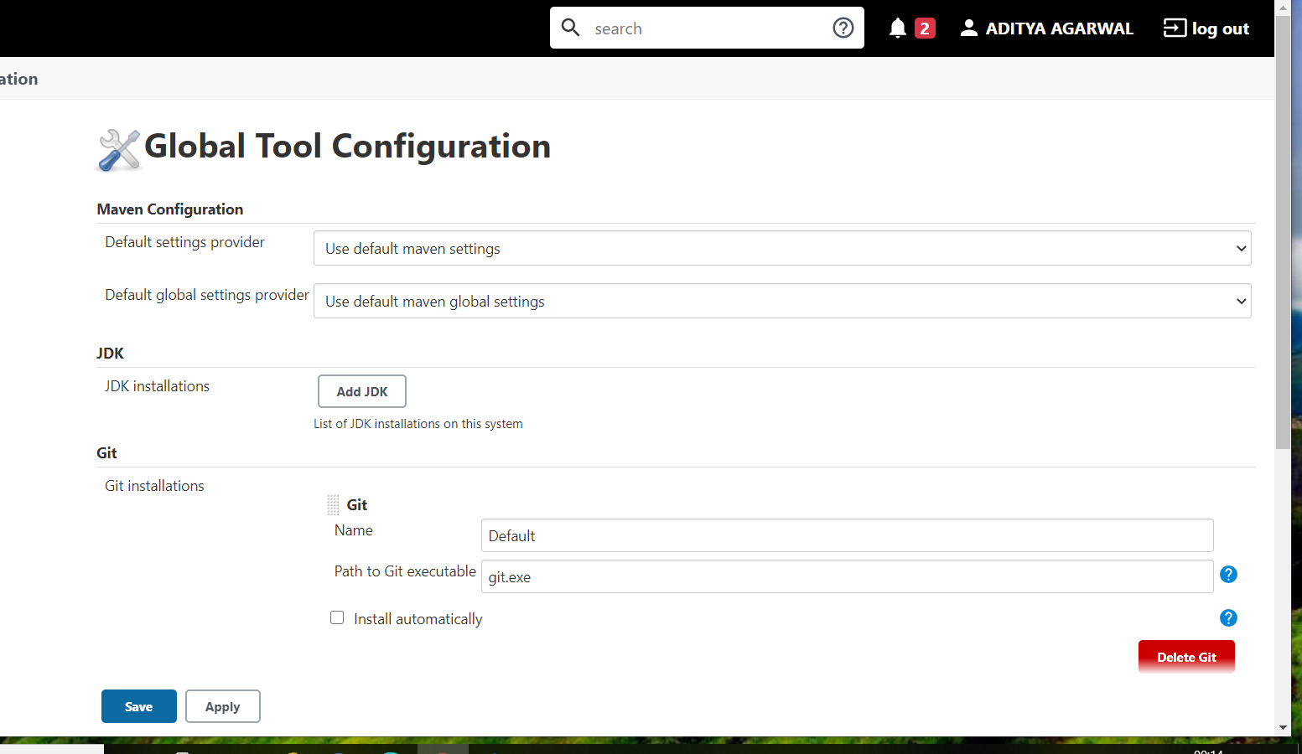

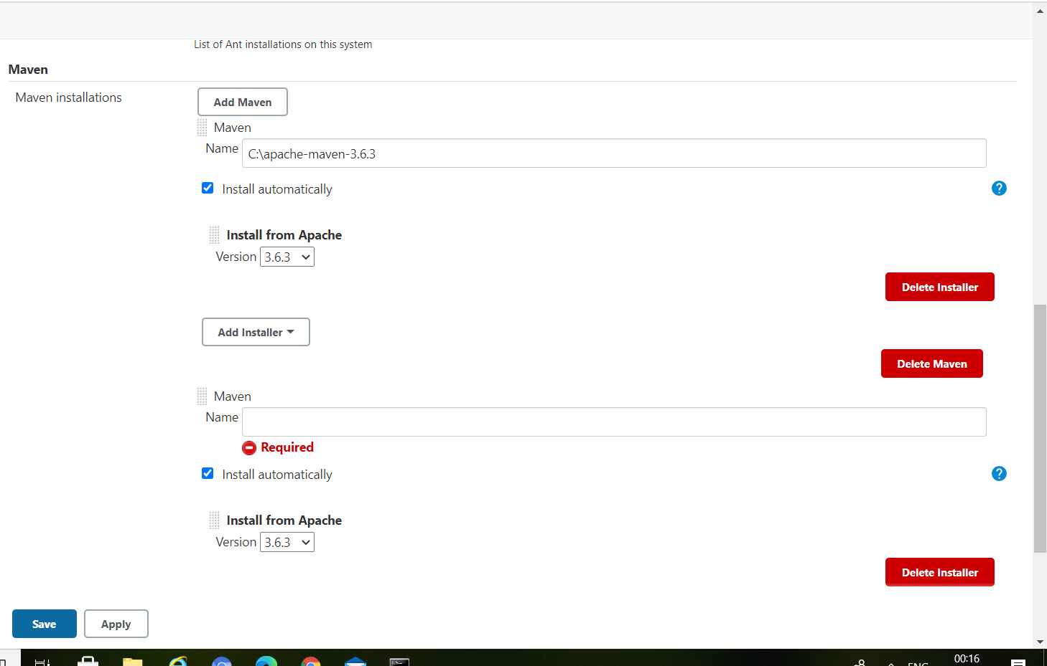

Give GitHub repository URL from where Jenkins will download Maven project

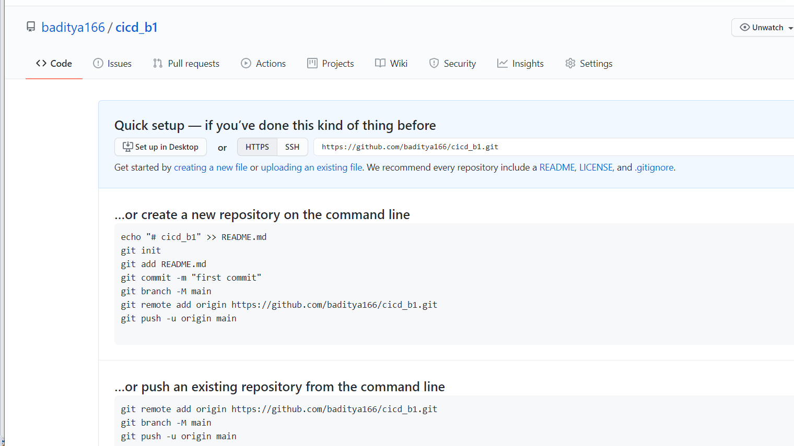

Make a maven project in eclipse

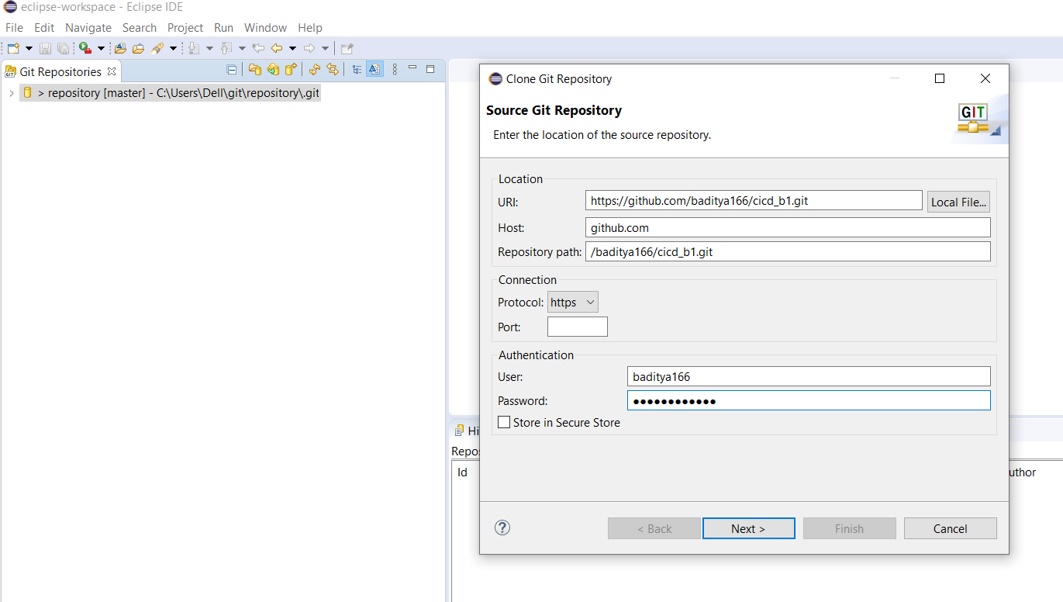

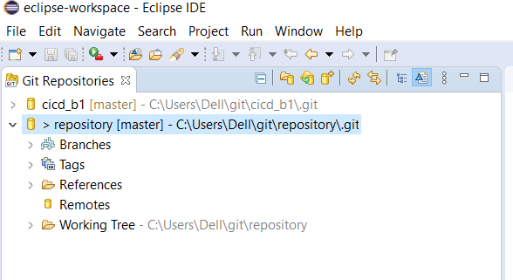

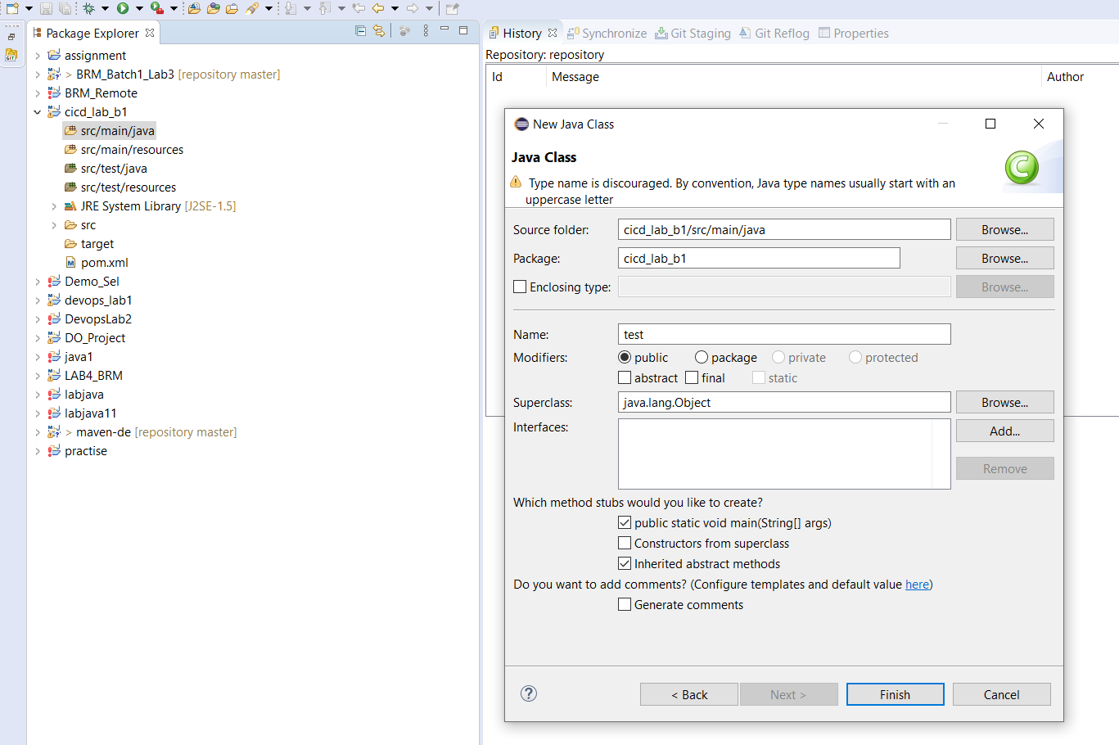

Commit the file

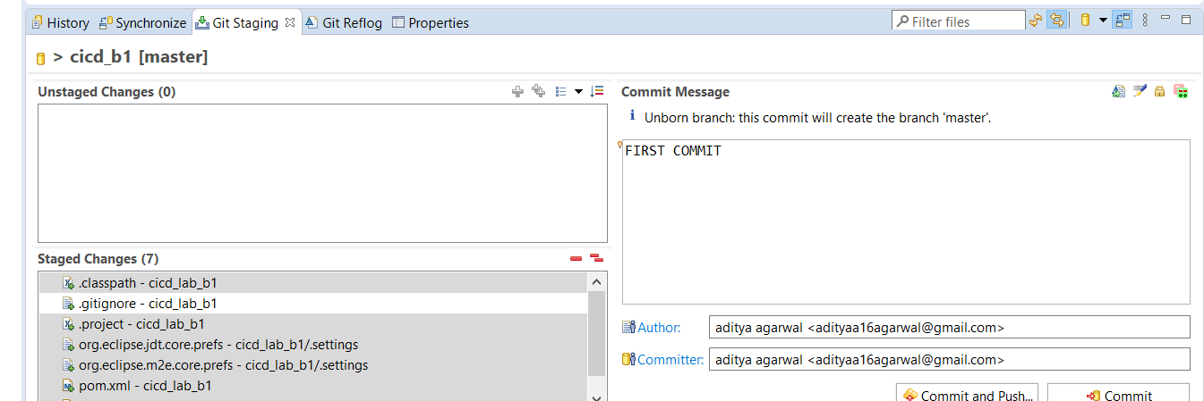

Push it to the git hub repository.

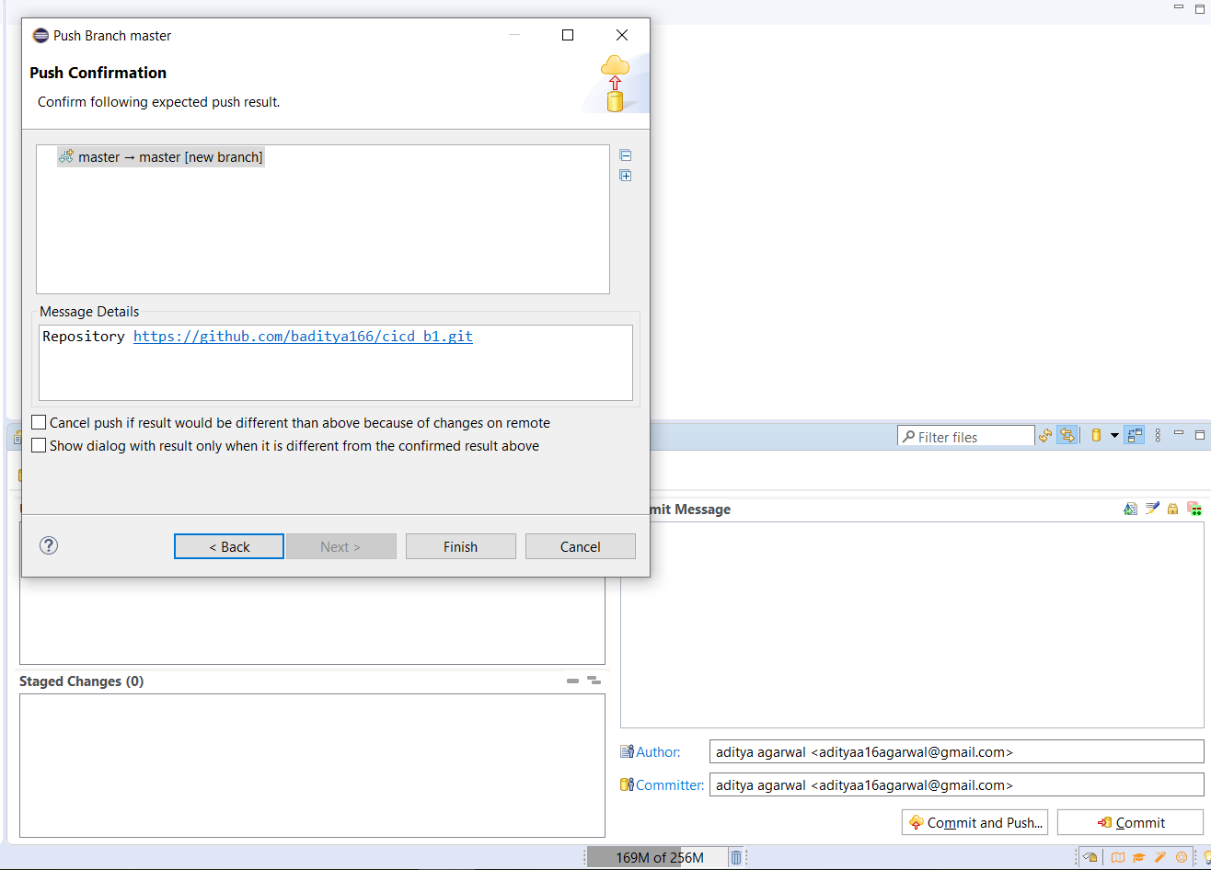

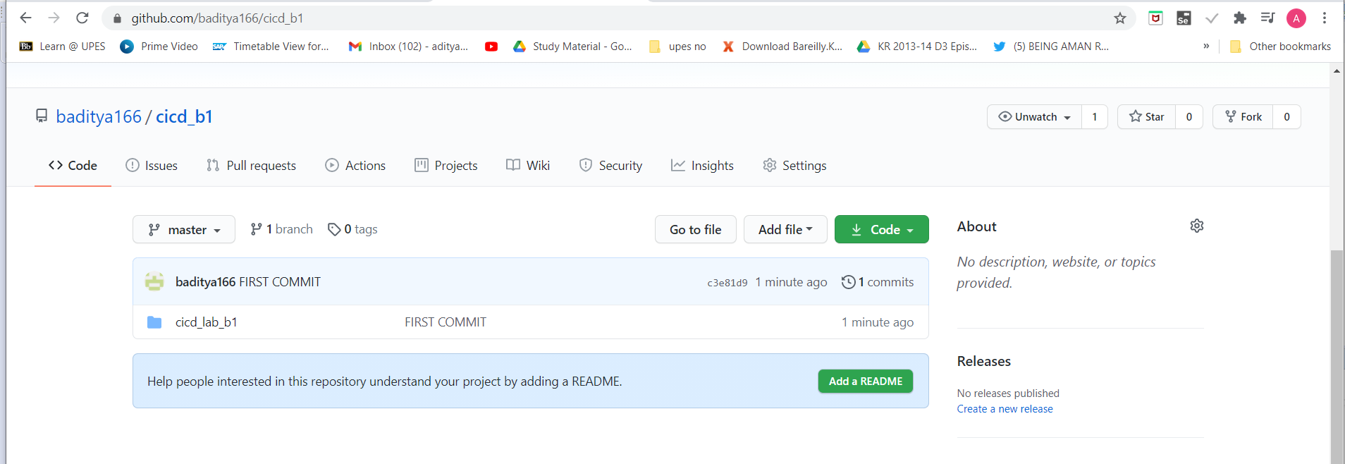

Go to Jenkins ,select maven project and add the github repository link.

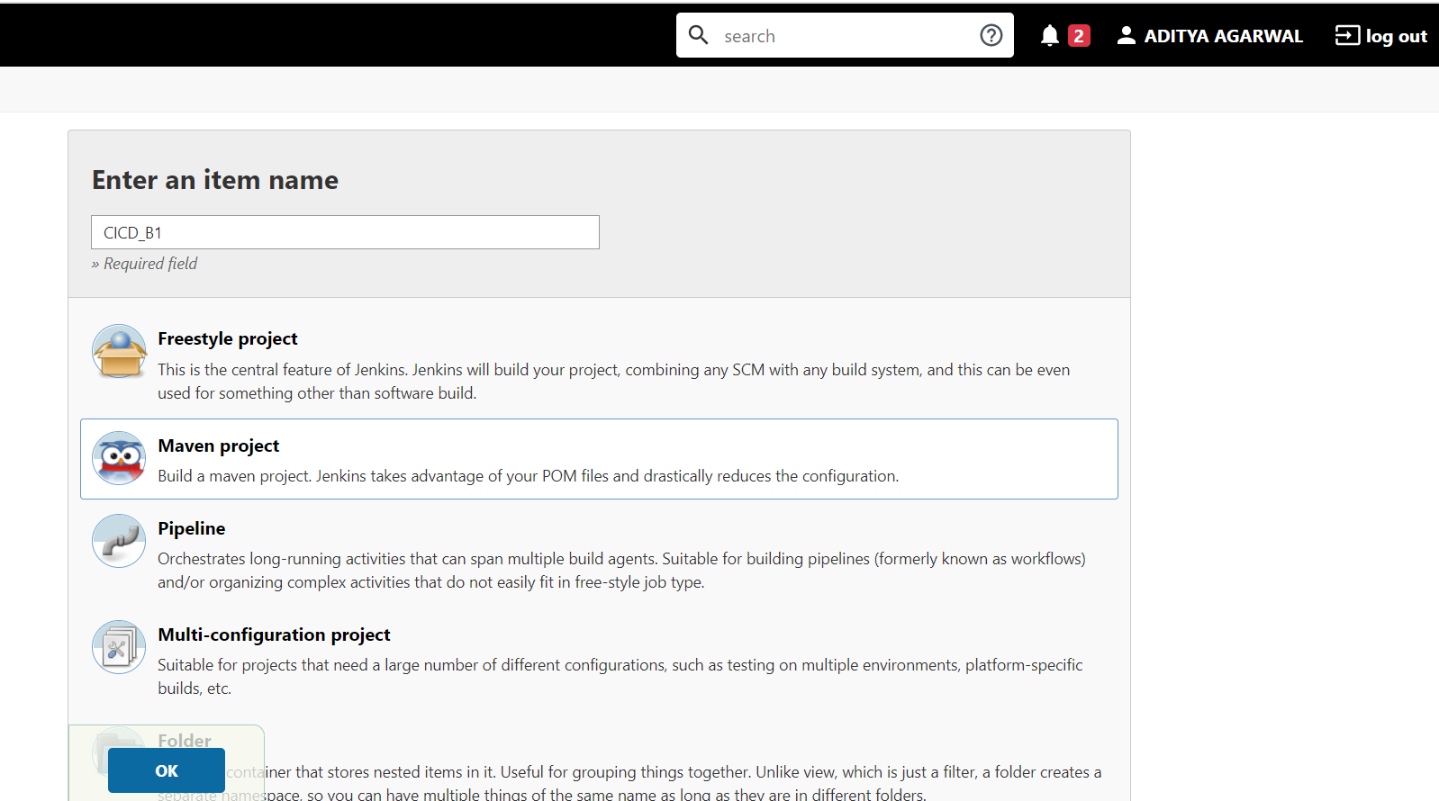

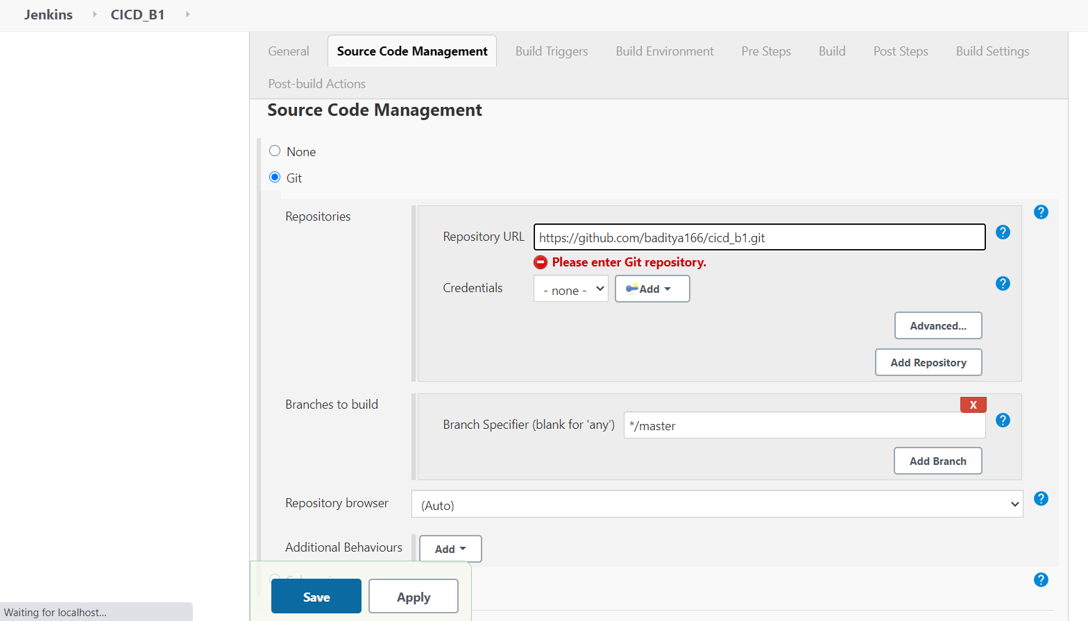

Give the location of pom.xml file and write maven goals which you want to run.

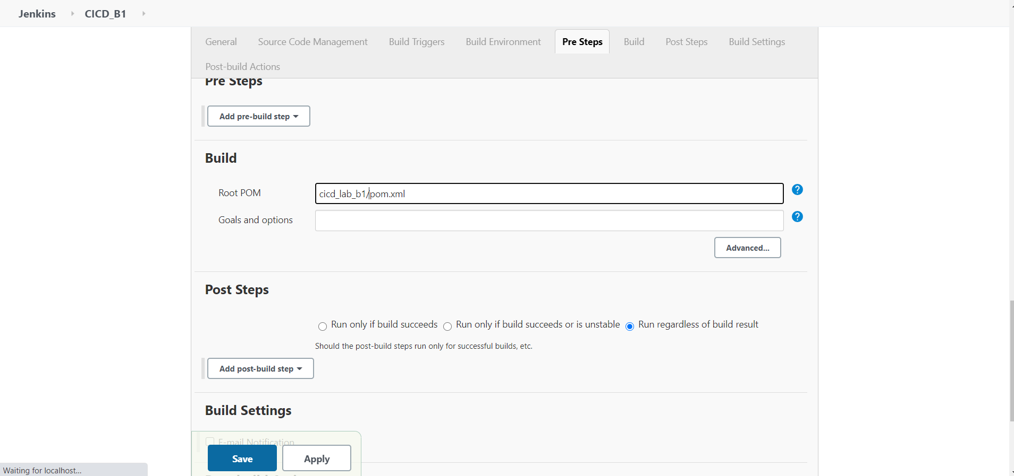

Now build it .

